COS225 Assignment #5 Name: Nicholas Soucy
Due: Friday 3/9/18

Part I: (20 pts.)

1. (2) When using a singly linked list to implement a queue, the ____ should be the front of the queue.

a. head node

2. (2) When using a singly linked list to implement a queue, the ____ should be the rear of the queue.

d. either head node or tail node as both implementations have the same efficiency
It could be b. tail node because it is more efficient for the front to be the head, then you would implement the tail node to be the rear because that is what is left. However, if we talk about the rear of the queue on its own, then it doesn’t matter if it’s the head or tail, it’s the same efficiency.

3. (2) The LinkedQueue class throws the EmptyCollectionException exception during _________ operation(s).

e. dequeue and getFront

4. (2) Any application that could be solved using the handwritten ArrayQueue class could also be solved using the handwritten LinkedQueue class.

a. True – however, one or the other is more likely to be efficient depending on the problem.

5. (2) The Java Queue interface offers a method named _________ to insert an element to the rear of the queue.

a. add

6. (2) Indicate all of the situations that suggest FIFO behavior in a word processor program. There may be more than one correct answer.

a. Issuing five File / Print commands in succession

7. (2) The ______________ collection in the Java Collections Framework stores objects that are processed in order of importance by some data member.

c. PriorityQueue

8. (2) Fill in the code to create a reference named c of the generic Collection interface of type String and instantiate with a LinkedList object.

Collection<String> c = new LinkedList< > ( );

9. (4) Using the refence named c in Question #8, indicate all methods that may be called. There may be more than one correct answer. Note only the method name is listed in the choices.

b. c.add
c. c.contains

Part II: (80 pts.)

Screen shot #1 to submit: This example illustrates catching an invalid transport item "grape".

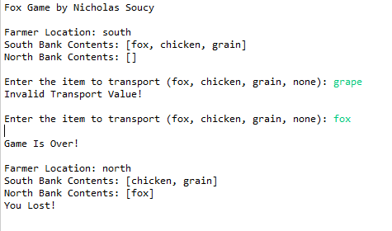
Screen shot #2 to submit: This example illustrates catching an invalid transport item that is one of the four items but does not exist on the current bank.

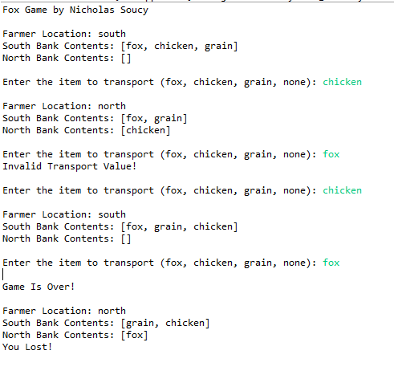

Screen shot #3 to submit:
Turn in a screen shot of a winning solution. You do not need to show any error messages.

